**Project Name:** PelReviews

**Project Members:** Christian Flores, Deivis Leung, Tomas Ponce, Keanna Vitug

**Purpose:** A website that allows users to read reviews of products, entertainment, locations, rate articles, and create articles themselves.

**Link to Website:** <http://pelreviews.000webhostapp.com/>

**Execution/Navigation of Website**

= highlighted section

* **View an article:**  Pick From one of the three main topic of PELReviews (Products, Entertainment, Location) and click on the dropdown menu. From there you are given subtopics that are part of the broader subject. A list of articles is then presented to you with varying subjects, and interests under that subtopic. Brows and click on one of the topics.





* **Search Bar**: In order to use the search bar of the website one can just type in what you are searching for in the white bar at the top of each page and then press enter. A list of results will appear after pressing enter, giving you the option to go to a specific page of the website



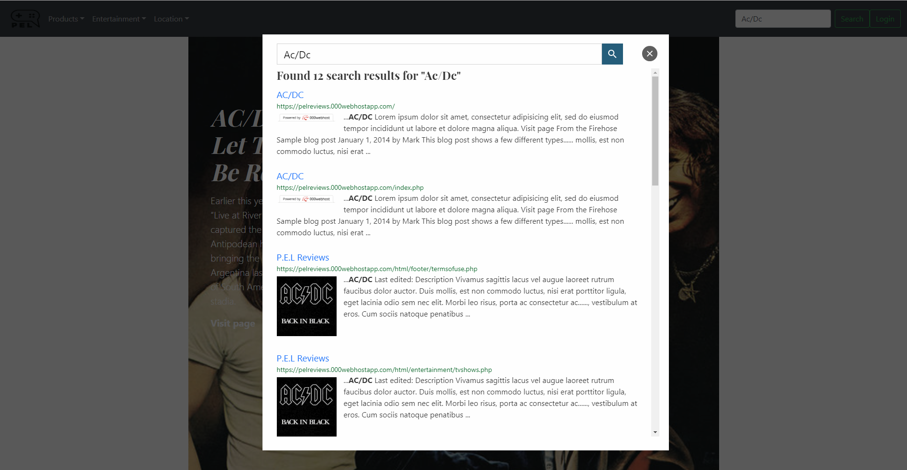

* **Adding Comments to an article**: In an article one can add comments to them by simply scrolling down towards the end of the article. At the bottom of each article there’s a section called “*Post a comment”*. In the section one simply fills out the required information and then press the submit button in order to post the comment on the article. If the user is already logged in, the user can simply enter a comment and press the submit button.

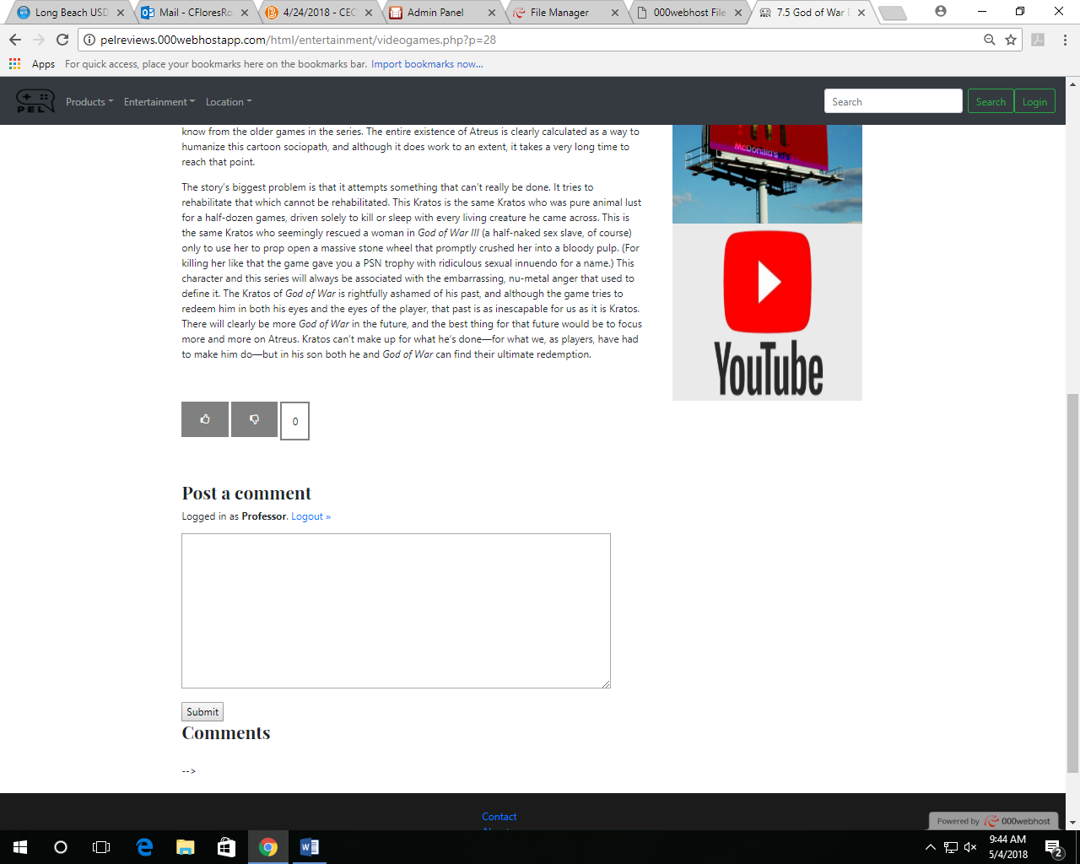

* **Liking an article**:One can also “thumbs up/thumbs down” an article by scrolling towards the end of an article. Before the comment section, there’s two button representing a thumbs up and a thumbs down. If a user liked the article they simple press the thumbs up button and if they disliked it they can press the thumbs down button.



* **Login in to your account**: In order to log in to your account, you can simply press the login button in any page of the website in order to login. After pressing the login button it takes you to the login page where it tells you to input your username and password to log on.
  + **Username**: cecs343
  + **Password:** csulb



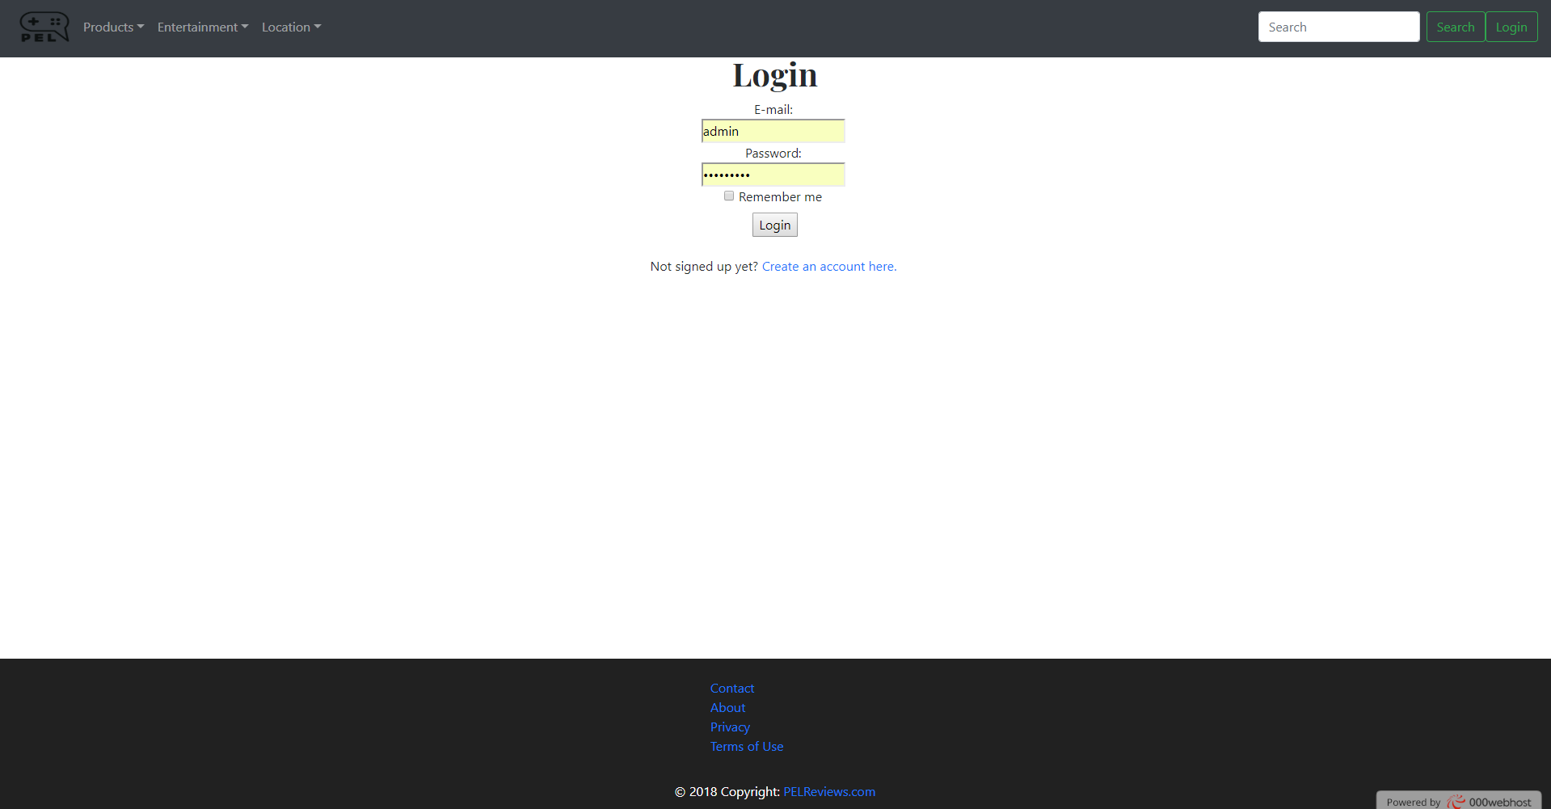

**Create an Account Page:**



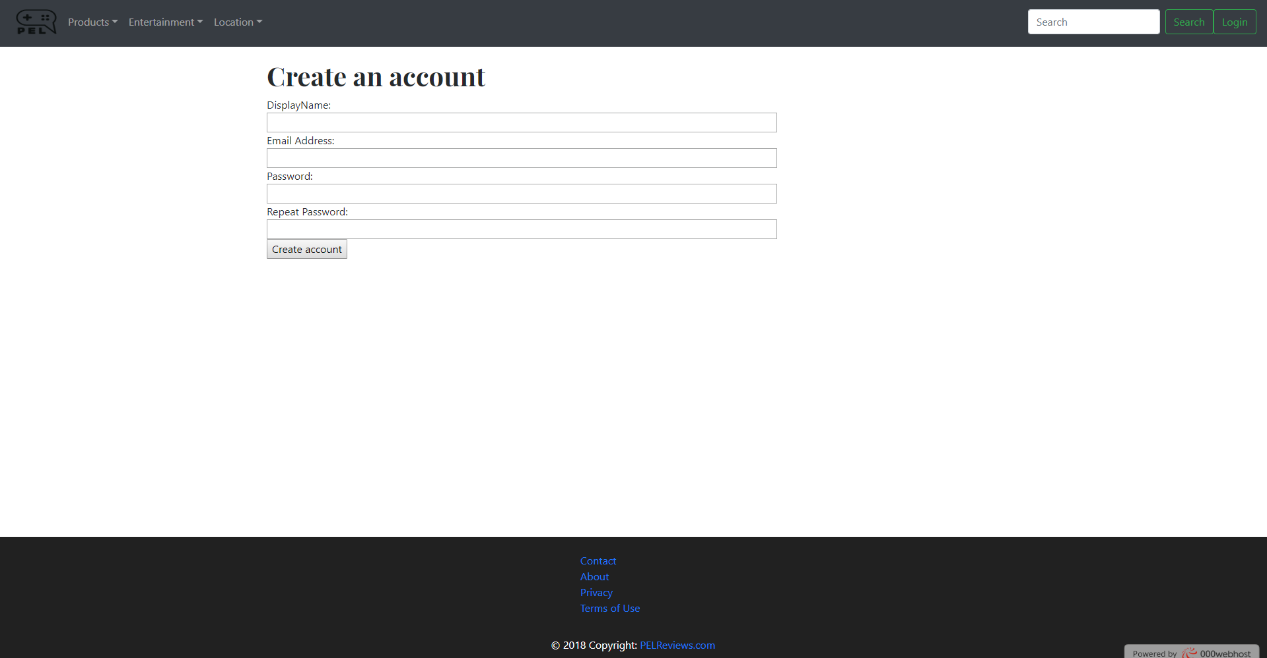

**List of Users that have created an account**

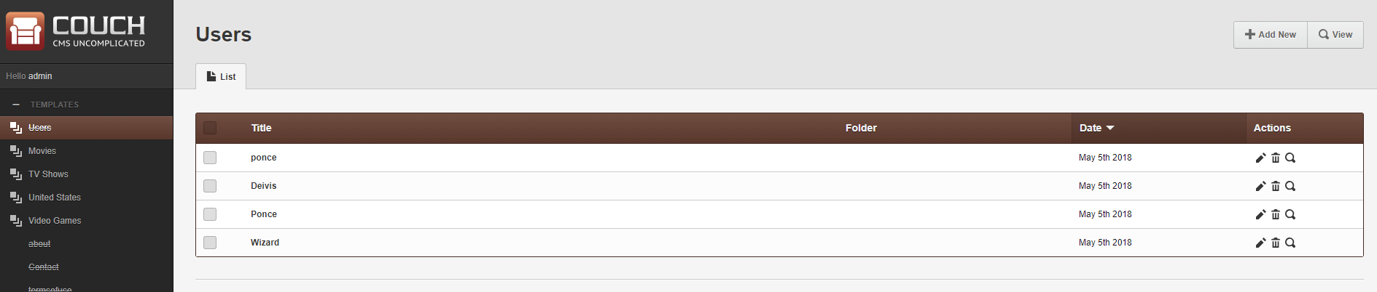

* **Posting an article:** To post an article on the website, one has to be logged on. After logging on, the account has a list of pages that website contains on the left side of the screen. To add an article you simple pick the section you want to add the article to. After clicking the section, one presses the “**Add New”** button that is located on the top right side of the monitor right new to the **“View”** button. From there the user can make there article according to how they desire and simply press the submit button.

